FALFIELD PARISH COUNCIL
FINANCIAL MATTERS REPORT STATEMENT
Presented to the Annual Parish Council Meeting held on 16th June 2025
Contents
Introduction 5
Bank Reconciliation 5
Bank Statements 6
Current Account 6
Unity Trust Bank - Instant Access Account 7
Receipts 8
Transfers 8
Schedule of Payments 8
Payments requiring approval of the Council 8
Direct Debit Payments 8
Supporting documents confirming payments 9
Voucher No: 16 – E.on Next 9
Vouchers No: 17 & 18 Redacted 10
Voucher No: 19 – F J Carpenter 11
Voucher No: 20 – Unity Trust Bank 14
Budget & Expenditure to date for the Financial Year ending 31st March 2026 15
Councils Earmarked Reserves 15
Financial position as of 16th June 2025 16
Community Infrastructure Levy Income 16
16
Summary of Receipts and Payments to date for 2025/26 17
Summary of projected budgeted income & expenditure for 2025/26 18

Introduction

This is a new format in order to take into account the requirements of the Councils Financial Regulations which were amended and adopted in April 2025.
During the Council meeting Councillors will approve by resolution the Bank Reconciliation displayed below which will then be signed by the Chair and Clerk.
This report also provides information on the Schedule of Payments on page 6 which again Councillors will be asked to approve by resolution for payment and/or note accordingly. The Chair will then be asked to initial the against each payment and also initial and date each supporting document.

Bank Reconciliation
The Clerk can report the following balances as of 31st May 2025 were as follows:
.

The Chairman and Clerk signed the Financial Report to confirm the above balances against the appropriate bank statements displayed on pages 3 and 4 of this Financial report.
Signed – Chairman: Date: 16th June 2025

Signed – Clerk & RFO: Date: 16th June 2025

Bank Statements

Current Account
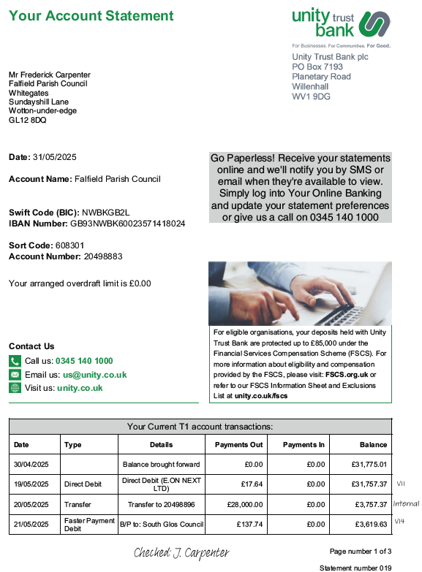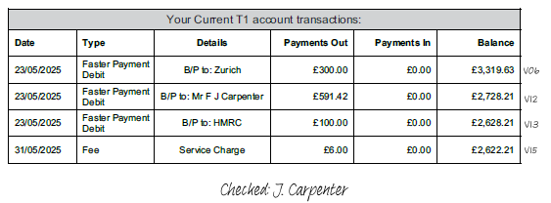

Unity Trust Bank - Instant Access Account

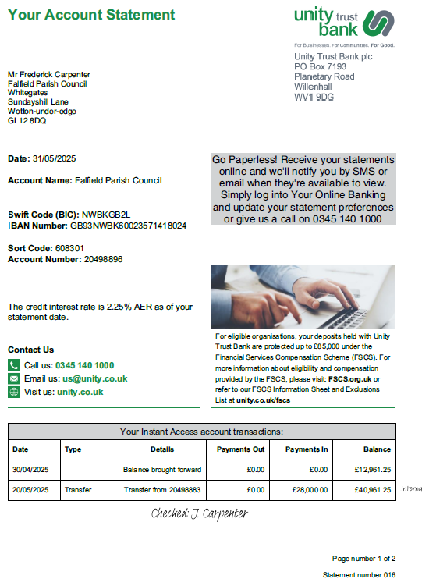

Receipts
There have been no receipts since the last meeting.
Transfers
There have been no receipts since the last meeting.

Schedule of Payments

Payments requiring approval of the Council
To RESOLVE payment of invoice(s) having been verified by the Clerk as accurate and have either been paid prior to this meeting or are now due for payment.
Vou | Description | Supplier | VAT | Net | Total | Powers to spend | Initialed by Chair
17 | Staff Salaries for June 2025  Redacted | F J Carpenter | 0.00 | 591.42 | 591.42 | LGA 1972 s112
18 | PAYE for June 2025 | H M Revenue & Customs | 0.00 | 100.00 | 100.00 | LGA 1972 s112
19 | 1st qtr Office Expenses | F J Carpenter | 0.00 | 30.00 | 30.00 | LGA 1972 s111
19 | 1st qtr Admin costs | F J Carpenter | 6.25 | 31.22 | 37.47 | LGA 1972 s111
Following approval of the above payments two Councillors will be requested to complete authorisations through the online banking portal.

Direct Debit Payments
Payments previously made or now due
Vou | Description | Supplier | VAT | Net | Total | Date of payment made/due | Powers to spend | Initialed by Chair
16 | E.on Next | May utilities | 1.00 | 19.91 | 20.91 | 18/06/25 | LGA 1972 s111
20 | Unity Trust Bank | June Service Charge | 0.00 | 6.00 | 6.00 | 30/06/25 | LGA 1972 s111

Supporting documents for all the above payments can be found on pages 7 to 10 of this report.

As per 6.3 of the Councils Financial Regulations all payments listed in the above Schedule of payments has been examined by the Clerk for arithmetical accuracy, analysed to the appropriate expenditure heading and verified to confirm that the work, goods or services have been received, or are expected to be received following payment.
Also as per 6.8 of the Councils Financial Regulations the above Schedule of Payments following its review by the Council for compliance and, having satisfied itself authorised payments by resolution will be initialled by the Chair of the meeting.

Supporting documents confirming payments
Voucher No: 16 – E.on Next
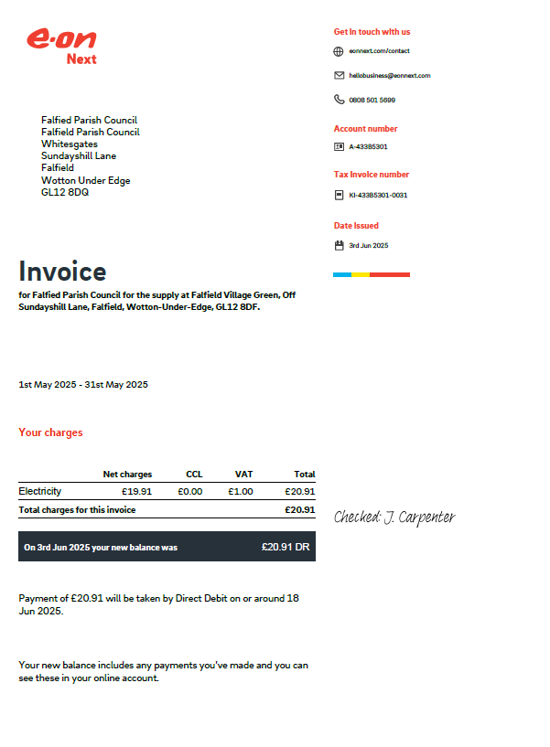
This Direct Debit payment was re-approved by the Council on 19th May 2025
Initialed by Chair of meeting

Vouchers No: 17 & 18 Redacted
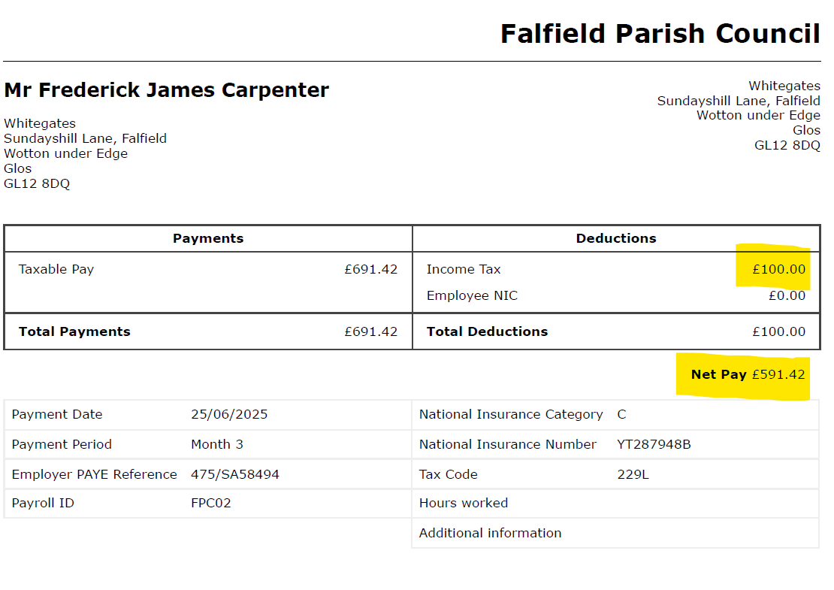

REDACTED

Initialed by Chair of meeting

Voucher No: 19 – F J Carpenter

Supporting documents can be found on pages 9 to 11.

Initialed by Chair of meeting

March invoice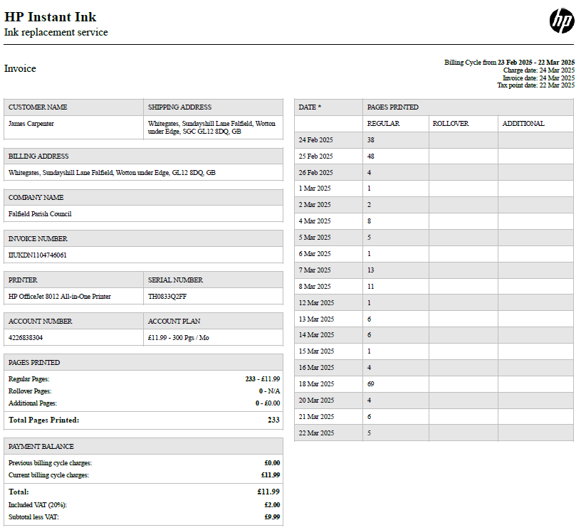
April Invoice
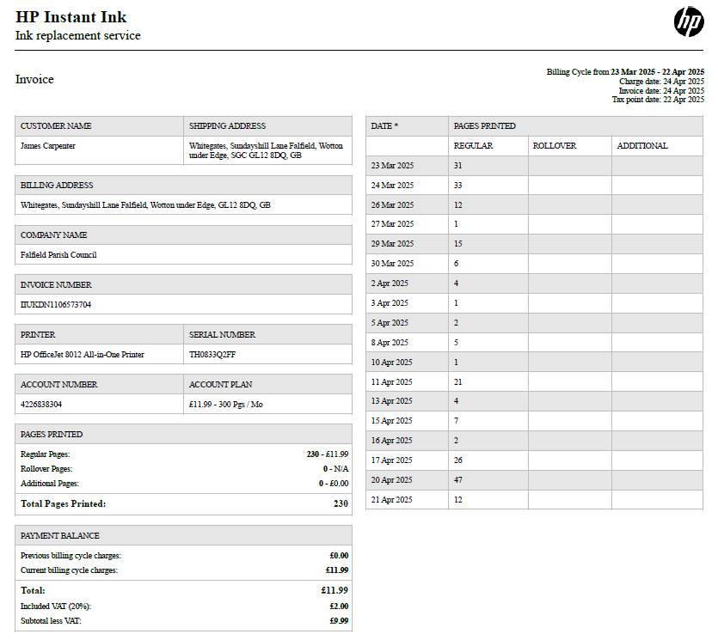

May invoice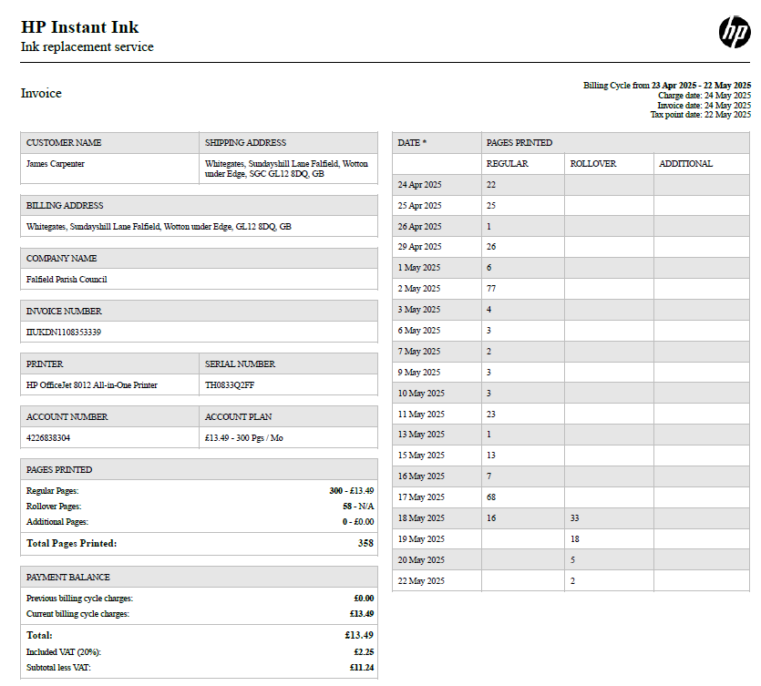
Voucher No: 20 – Unity Trust Bank
This is a monthly charge of £6.00 which is applied on the last day of each month.

This Direct Debit payment was re-approved by the Council on 19th May 2025
Initialed by Chair of meeting

Budget & Expenditure to date for the Financial Year ending 31st March 2026

Councils Earmarked Reserves

Financial position as of 16th June 2025
The figures below include the receipts, transfers and schedule of payments detailed on page 5 of this report.
Community Infrastructure Levy Income
The committed outgoing figures are net of VAT unless otherwise stated.
As a reminder, CIL contributions can be spent on:
- The provision, improvement, replacement, operation or maintenance of infrastructure; or,
- Anything else that is concerned with addressing the demands that development places on it.
CIL income must be spent within five years from its initial receipt after which time any income not spent must be returned to South Gloucestershire Council. Therefore of the remaining £30,549.10 still to be spent the following amounts reach their 5 years as follows:
£ 5,168,68 before April 2028
£ 7,709.19 before April 2029
£ 18,076.23 before April 2030

Summary of Receipts and Payments to date for 2025/26
Receipts from 1st April 2025
Payments made from 1st April 2025
Current status of Councils finances (which includes payments for approval at the meeting on 16th June 2025)

Summary of projected budgeted income & expenditure for 2025/26

